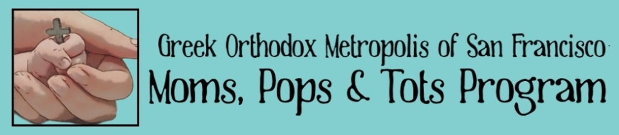
Moms, Pops n’ Tots
2015-2016 Registration

Moms n' Tots is a faith-based program for moms/pops/nanny/grandparent of young children between the ages of 6 months and 3 years. The program is structured to provide interactive activities related to various themes in the Orthodox Church. Weekly activities include: prayer, lessons, music & movement, crafts, snacks, and playtime. We also have various field trips, outings, visits to the sanctuary and class party planned.

Classes meet ____________ from _________
(day) (time)

Location (parish address/room number)

Registration Fee:____ per child

(Determined by the parish)

Teachers:______________ and _____________
(Names- optional contact #)

“And He took the children in His arms, put His hands on them and blessed them”. Luke 10:16
------------------------------------------------------

Child’s Name: _____________ Birth Date ___/___/___

Child’s Name: _____________ Birth Date ___/___/___

Parents’ Names: ______________________________________

Address: ____________________________________________

Phone: (home) __________________ (cell) ____________

Email: _______________________________

Person attending with the child ________________

